**GIT LAB #01**

***Screenshot #01***

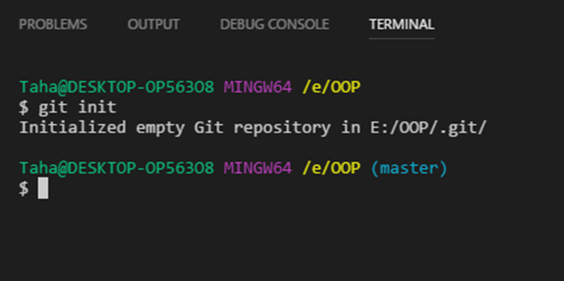

***Screenshot #02***

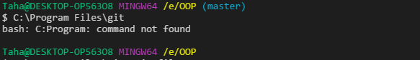

***Screenshot #03***

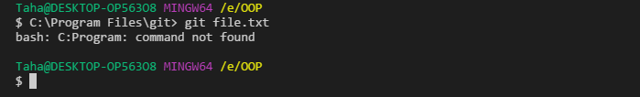

***Screenshot #04***

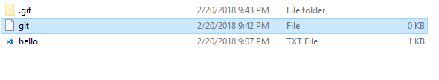

***Screenshot #05***

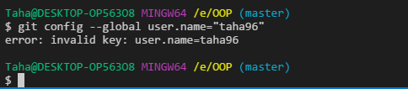

***Screenshot #06***

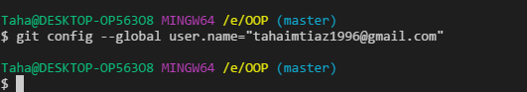

***Screenshot #07***

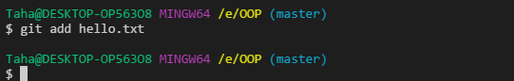

***Screenshot #08***

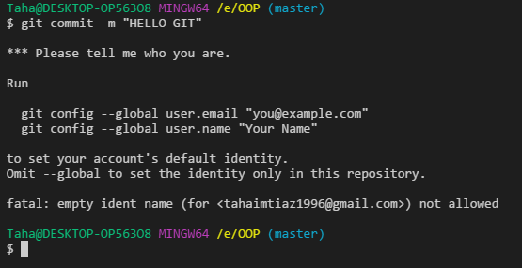

***Screenshot #09***

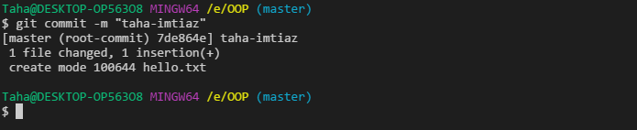

***Screenshot #10***

